MaRG Referral Form and guidance notes

- Eligibility for the Panel
The Multi-agency Resolution Group (the Panel) is designed to consider any cases where the person is experiencing multiple disadvantage. This includes, but is not limited to, combinations of homelessness, substance misuse, social care, mental ill-health, domestic abuse, hoarding, etc., where the person’s progress is stuck as they are not engaged in the services needed to manage risk at an acceptable level. Before referring, lead support agencies are expected to have taken normal steps to coordinate multi-agency working. You should also note that the referring agency will continue to lead the case – the Panel can “unlock” other services, but does not hold cases itself.

- Signing up to the information sharing protocol and agreement
Before making your first referral, your organisation must have signed the information sharing protocol and information sharing agreement. This only needs to be done once by your organisation, and can be submitted electronically. It should be done by a named individual with appropriate authority to agree this on the organisation’s behalf. These set out your organisation’s commitment to how data will be shared and what protective measures will be put in place. Until these two documents have been approved by your organisation, we cannot accept a referral from you.
- Agreeing participation with the client
We believe it is important that we are completely transparent with the individuals you are working with. The participation agreement acts as a script that you can talk through with your client that sets out how the panel works and how their information will be used. There is also space for them to say if they do not want their information shared with a specific agency, and we will always try to comply with their request. Both you and the client should sign the participation agreement, and you should ensure that you have two copies – one for the client to keep, and one which you must send with your completed referral form.
- Completing the referral form
The referral form is in two parts. The first part is a case history, and you only need to complete this part to submit an initial referral. The second part will only need to be completed after you have presented the case to panel, and further guidance will be provided at that stage if you need it.
There are prompts in italic font throughout the form to help you complete it, and to prompt the conversation. You should overtype the italics when you are completing the form. It is important to fill out the form as comprehensively and concisely as possible so the panel can consider all elements of the case.

- Submitting the referral form
Please send your completed referral form, consent form and the accompanying participation agreement to marg.sp@stoke.gov.uk in the subject field please quote the initials of the client. Please ensure that you send forms securely and mark as Confidential and Sensitive. All referrals must be received 2 weeks prior to the planned MaRG meeting date, which will be held on the first Tuesday of each month.
- Presenting your client’s case to the panel
The expectation is that all cases will be presented to the panel by the lead agency and the person with the most customer knowledge, so that you can fully discuss the details of the case and receive advice from the panel directly. Generally, we will aim to confirm at least a week in advance what slot you have been allocated at a panel meeting. We do not know how many referrals to expect each month, and we may have to prioritise referrals to hear the most urgent cases first. As such there may be a delay in your being invited to present your case. We will keep you informed and will always aim to give you as much notice of possible of the available slots.
If you have any questions or need support with any element of this process, please contact marg.sp@stoke.gov.uk, providing your contact details, and we will ensure that someone calls you back.

MaRG Timeframes

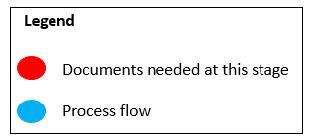
Flowchart of the referral process

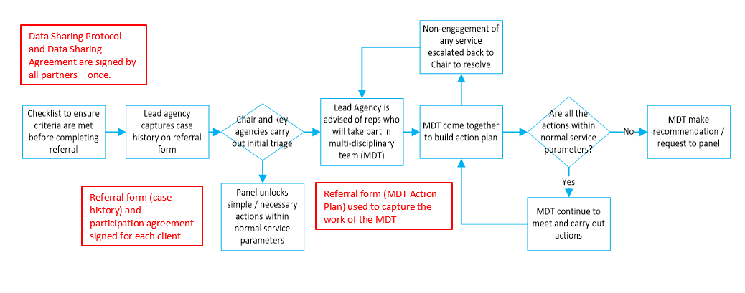

Pre-referral Checklist
Before completing the MaRG Referral Form, please make sure you read the checklist below. Referring a case to this panel should not stop you from taking any other necessary actions or contacting other relevant agencies where appropriate.

MaRG Referral Form and Action Plan
Before completing this referral form, make sure that your organisation has signed up to the information sharing protocol and data sharing agreement.
Referrer details
Lead agency: |  |  |  |  | Contact number:
Name of referrer: |  |  |  |  | Email address:
Your manager: |  |  |  |  | Date of referral:
Client details
Full name: |  |  |  |  | GP name:
Date of birth: |  |  |  |  | GP contact details:
Correspondence address:
Legal basis for sharing confidential information (check at least one)
There is informed consent  to share information |  |  | There is implied consent  to share information |  | There is a legal duty  to share information |  | A legal power to share information is being applied

Part 1: CASE HISTORY
From the list below, please tick any of the areas that you will be discussing in the case history?
Clients views  must be captured in all cases | Housing status | Substance use | Mental health | Harm from others | Perceived risk to others | Sex workers
Clients views  must be captured in all cases | Physical health | Income and financial status | Engagement with services | Relationships | Hoarding or concerns around self-neglect | Offending

The pre-populated italic text within the fields is for guidance only. Please overtype this text when completing the form.
Area | For each of the applicable areas, please write your comments regarding the four listed points:  1. History  2. Current status, engagement and specifics  3. What actions have already been taken?  4. Risks?
Housing Status: | History Temporary accommodation, B&B accommodation, ‘sofa surfing’ with friends and family, in assessment centres, released from prison or hospital, rough sleeping  Current status. Engagement? Specifics E.g. Eviction notice served? Asked to leave by family or friends? Homeless and engaged with services?  What actions have already been taken?  Risks?
Substance use: | History Is there use of drugs or alcohol in the last 2 years, 12 months, 6 months?  Current status. Engagement? Specifics Is there current substance use? Undergoing treatment? Is the client stable and engaged with services? Is there problematic behaviour?  What actions have already been taken?  Risks? Dual diagnosis
Mental health: | History Is there any mental health condition? Have there been repeat presentations to health services? Recent inpatient hospital admission or discharge?  Current status. Engagement? Specifics, Diagnosis Is there a diagnosis? Does behaviour suggest low/medium/high risk to self or others? Is any prescribed medication being taken or current engagement with health service?  What actions have already been taken?  Risks?
Harm from others: | History Is there past abuse/exploitation from others/society?  Current status. Engagement? Specifics Is there concern of current abuse/exploitation from others/society?  What actions have already been taken?  Risks?
Perceived risk to others: | History Is there past ASB? Is there dangerous/criminal/offending behaviour to others?  Current status. Engagement? Specifics Risk to property and/or low/medium/high risk to physical safety of others  What actions have already been taken?  Risks?
Sex workers | History  Current status. Engagement? Specifics  What actions have already been taken?  Risks?
Offending: | History Historic police cautions, criminal convictions etc. as adult or juvenile, Section 5 Public Disorder Act? Is there prolific offending?  Current status. Engagement? Specifics Is this impacting on ability to secure accommodation? Has there been a sentence in the last year? Are there conditions on release? Tag/curfew/order?  What actions have already been taken?  Risks?
Physical health: | History Are there chronic physical health issues? Is there prescribed medication to manage this? Is there regular use of A&E or inpatient services?  Current status. Engagement? Specifics What is the current physical health condition and treatment? Is there a requirement for treatment or hospitalisation?  What actions have already been taken? GP/secondary care engagement?  Risks?
Income and financial status: | History Explain the financial status. Income/expenses. Are there priority and non-priority debts? Do they have necessary paperwork to apply for benefits? (E.g. Photo ID)?  Current status. Engagement? Specifics Is there a current income? Does debt require agency intervention? Are debts putting client at risk of homelessness?  What actions have already been taken? Has the client claimed all entitlements?  Risks?
Engagement with services: | History Provide details of past engagement with services  Current status. Engagement? Specifics What services are still actively engaged with the client?  What actions have already been taken? What worked, what didn’t?  Risks?
Relationships: | History Does client have family, pets and friends?  Current status. Engagement? Specifics What support do they have, if any? Are there opportunities?  What actions have already been taken?  Risks?
Hoarding or concerns around self-neglect: | History  Current status. Engagement? Specifics What is the current Clutter Image Rating? Are there connections to family, church etc.?  What actions have already been taken? What other organisations have been engaged with?  Risks?
Client views: | History Record comments and views client wishes to highlight or add about their case?  Current status. Engagement? Specifics What are their main priorities at the moment? What would the client like to happen next?  What actions have already been taken? Any views on actions taken to date?  Risks?

Referrer case summary
Please write any additional comments you wish to highlight about the case.

Part 2: MULTI-DISCIPLINARY TEAM ACTION PLAN
The prepopulated italic text within the fields is for guidance only. Please overtype this text when completing the form.
Date of MDT meeting: Members of MDT:
Area | Discounted/considered options  Agreed actions | Action owner | Deadline | Risks?
Housing Status: | Discounted/considered options  Keep a record to help MDT and Panel easily identify what has been thought through already and why it has been discounted.  Agreed actions  - What actions are you committing to carry out? Be specific. Remember to engage with the client about the plan. What are their views? Manage expectations. | Make it clear who owns the actions. Where a panel decision is needed, please note them as the action owner and send an email of the completed referral form complexneedspanel@brent.gov.uk | What is the target date for this to be completed? | Date last reviewed, what is being done to mitigate this
Substance use: | Discounted/considered options  Keep a record to help MDT and Panel easily identify what has been thought through already and why it has been discounted.  Agreed actions  - What actions are you committing to carry out? Be specific. Remember to engage with the client about the plan. What are their views? Manage expectations.
Mental health: | Discounted/considered options  Agreed actions
Harm from others: | Discounted/considered options  Agreed actions
Perceived risk to others: | Discounted/considered options  Agreed actions
Sex workers: | Discounted/considered options  Agreed actions
Offending: | Discounted/considered options  Agreed actions
Physical health: | Discounted/considered options  Agreed actions
Income and financial status: | Discounted/considered options  Agreed actions
Engagement with services: | Discounted/considered options  Agreed actions
Relationships: | Discounted/considered options  Agreed actions
Hoarding or concerns around self-neglect: | Discounted/considered options  Agreed actions
Client views: | Discounted/considered options  Agreed actions

Request to Chair and Key Agencies
This referral form will be given to the panel and you will present your case to them. Please write any additional comments you wish to add. Consider actions that are outside of normal service parameter and what they may achieve.

